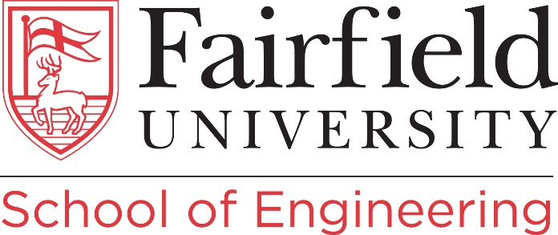

Tenure-Track Assistant or Associate Professor
Mechanical Engineering

The School of Engineering at Fairfield University invites applications for a tenure-track assistant or associate professor position in Mechanical Engineering with a start date of September 1st, 2023. Candidates in all areas of Mechanical and Aerospace Engineering are encouraged to apply.

Position Description:
This position requires an ability to perform teaching, scholarship, and service responsibilities. The successful candidate will be required to: (1) develop and teach undergraduate and graduate courses (lecture and laboratory); (2) supervise MS-level theses, undergraduate research, and Senior Design Projects; (3) pursue scholarly activities (including externally-funded research and peer-reviewed publications); (4) engage in academic advising and mentoring; (5) assist in program assessment, execution of the department’s continuous improvement plan and documentation in support of ABET accreditation; (6) participate in appropriate professional service; and (7) participate in professional activities and organizations. The position is an academic (9-month), tenure-track appointment, and the salaries are competitive and commensurate with qualifications and experience.
The School of Engineering at Fairfield University traces its legacy and rich history to the Bridgeport Engineering Institute (BEI), dating back to its founding in 1924 and through its merging with Fairfield University in 1994. The School of Engineering is organized into the departments of Electrical and Biomedical Engineering, Mechanical Engineering, and Computer Science and Engineering. The Department of Mechanical Engineering is ABET accredited and offers Bachelor of Science and Master of Science degrees with major in Mechanical Engineering. In addition, students have an option to obtain a Concentration in either Automation, Robotics, and Manufacturing or Aerospace Engineering. The department is equipped with state of the art laboratories such as Material Characterization Lab, Automation, Robotics and Manufacturing (A.R.M.) Lab, Mechanical Engineering Lab, Machine Shop Lab and Innovation Annex in support of teaching and research and has one of the highest enrollment within the School of Engineering.

Required Qualifications:
- Ph.D. in Mechanical or Aerospace Engineering (attained by August 1st, 2023)
- Effective English communication skills (verbal and written)
- Ability to teach effectively both undergraduate and graduate courses
- Demonstrated potential to prepare proposals and conduct funded research in the relevant field
- A commitment to innovation and demonstrated excellence in using technology in the classroom.

Preferred Qualifications:
While all areas of Mechanical and Aerospace Engineering are encouraged to apply, preference will be given to candidates with applied experimental research and/or teaching background in Robotics, Mechatronics, Automation, Intelligent Mechanical Systems, and Aerospace.
Screening of applications will begin immediately and will continue until the position is filled. Full consideration will be given to candidates who apply by November 1st, 2022. The preferred starting date is September 1st, 2023.
Please click here and upload the following materials. A complete application will consist of: (1) a cover letter addressing the qualifications (one page max), (2) a statement of teaching interests and research plan (two pages max), (3) a curriculum vitae, and (4) the names and contact information of three professional references (references will not be contacted without prior knowledge and approval of candidates). Only complete electronic applications submitted as a single PDF file will be considered. Inquiries about the position should be addressed to the Chair of the Search Committee, Associate Professor Harsha Sundarram (engineeringsearch@fairfield.edu).

Founded in 1942, Fairfield University is one of twenty-eight Jesuit colleges and universities in the United States. The University’s Jesuit and Catholic identity give rise to its vibrant education in the liberal arts, sciences, and professions that prepares students to lead their communities with insight, empathy, critical rigor, and a determination to serve and promote justice. Located in the coastal town of Fairfield, Connecticut, the University's 200-acre campus is just one hour outside New York City, in the heart of a region with the largest concentration of Fortune 500 companies in the nation.
For more information on Fairfield University, please visit www.fairfield.edu. For more information on the School of Engineering, please visit www.fairfield.edu/engineering.
Fairfield University is an Equal Opportunity/Affirmative Action employer, committed to excellence through diversity, and, in this spirit, particularly welcomes applications from women, persons of color, and members of other historically underrepresented groups. The University will provide reasonable accommodations to all qualified individuals with a disability. All offers of employment are contingent upon a satisfactory background check.

